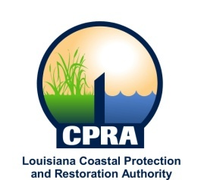

2019 Public Meetings

Chip Kline, Chairman of the Coastal Protection and Restoration Authority, and Executive Assistant to Governor John Bel Edwards for Coastal Activities has announced the public meetings schedule for the Coastal Protection and Restoration Authority and the Governor’s Advisory Commission on Coastal Protection, Restoration and Conservation. Details on each meeting will be sent out at a later date. The dates and locations of these meetings are subject to change.

CPRA
January 16, 2019
Baton Rouge, LA

February 20, 2019
New Orleans, LA

March 20, 2019
Baton Rouge, LA

April 17, 2019
Baton Rouge, LA

May 15, 2019
Baton Rouge, LA

June 19, 2019
Houma, LA

July 17, 2019
[CANCELLED]

August 21, 2019
Baton Rouge, LA

September 18, 2019
Luling, LA

October 16, 2019
Baton Rouge, LA

December 18, 2019
Baton Rouge, LA

Governor’s Advisory Commission
February 6, 2019
Baton Rouge, LA

May 1, 2019
Baton Rouge, LA

July 10, 2019
[CANCELLED]

September 11, 2019
Gretna, LA

November 6, 2019
Baton Rouge, LA

